Guide to the Kenya Railways Job Application

1. Introduction
This guide provides step-by-step instructions for candidates on how to search and apply for job opportunities via the job-link on the career portal of Kenya Railways website.

2. Prerequisites
- Valid email address
- Updated resume/CV (PDF or Word)
- Supporting documents (certificates, cover letter)
- Stable internet connection

3. Accessing the Career Site
- Open a web browser.
- Go to the Kenya Railways Website – www.krc.co.ke
- Click on the Career Tab.
- You will be able to review current openings
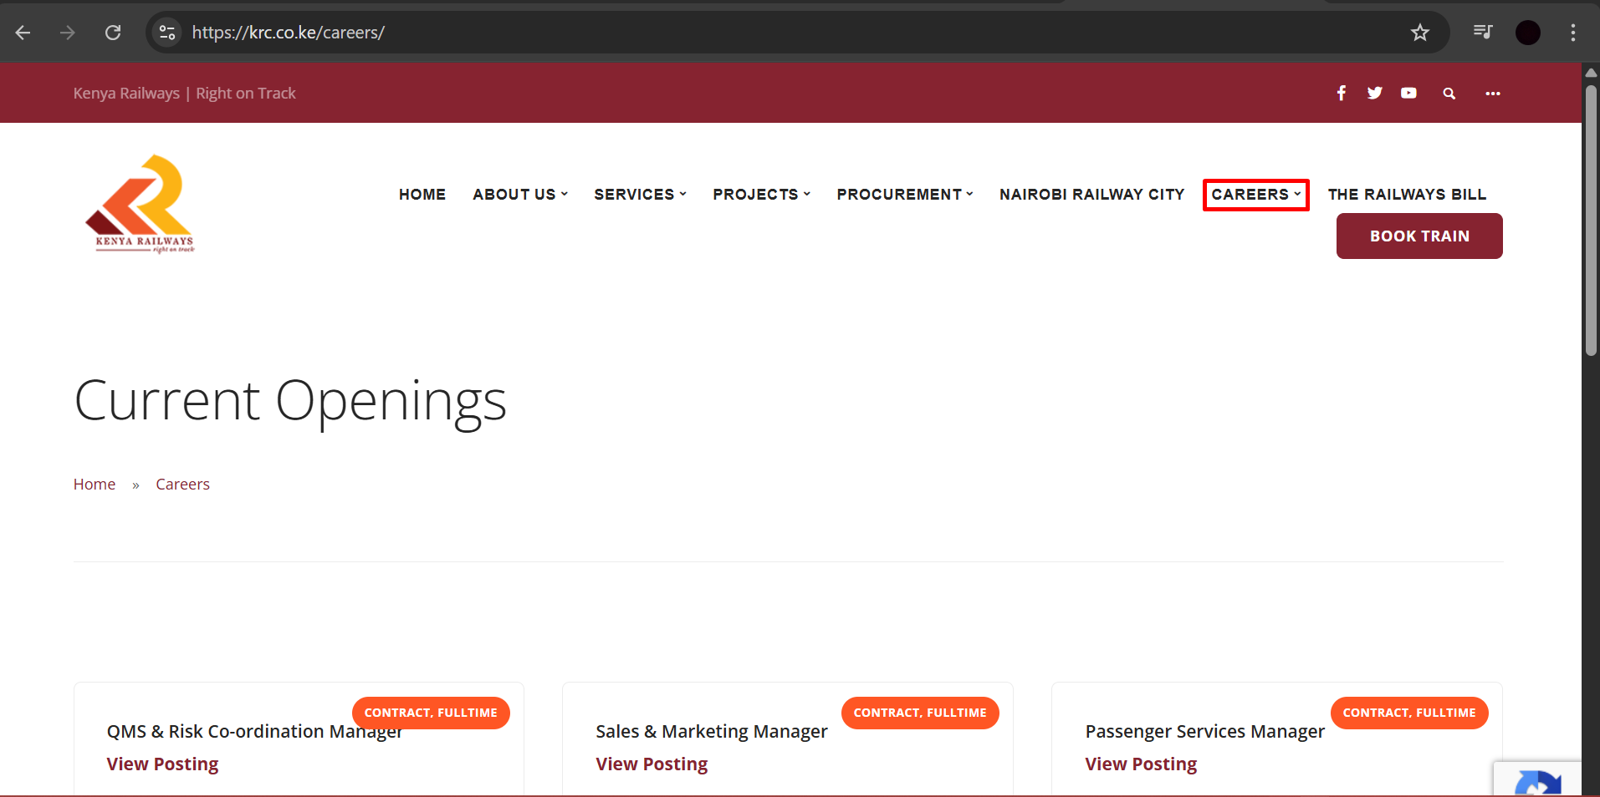

4. Viewing Job Details
- Click on “View Posting” of Specific Job Title
- Review description, responsibilities, qualifications, and deadline.
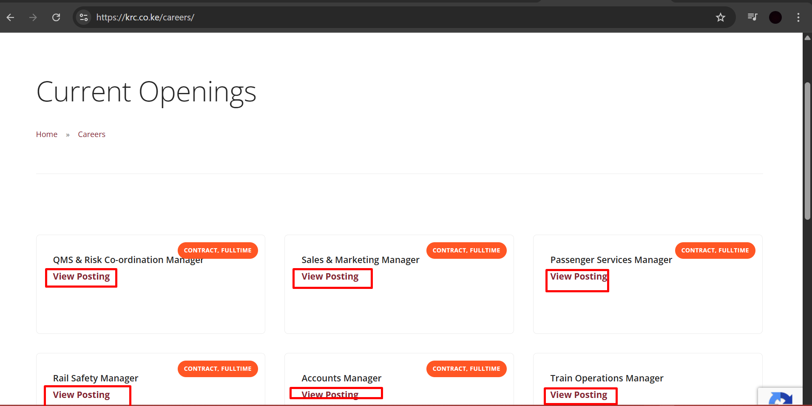

5. Creating a Candidate Profile
- Click 'Apply Now'.
- Select 'Create an Account'.
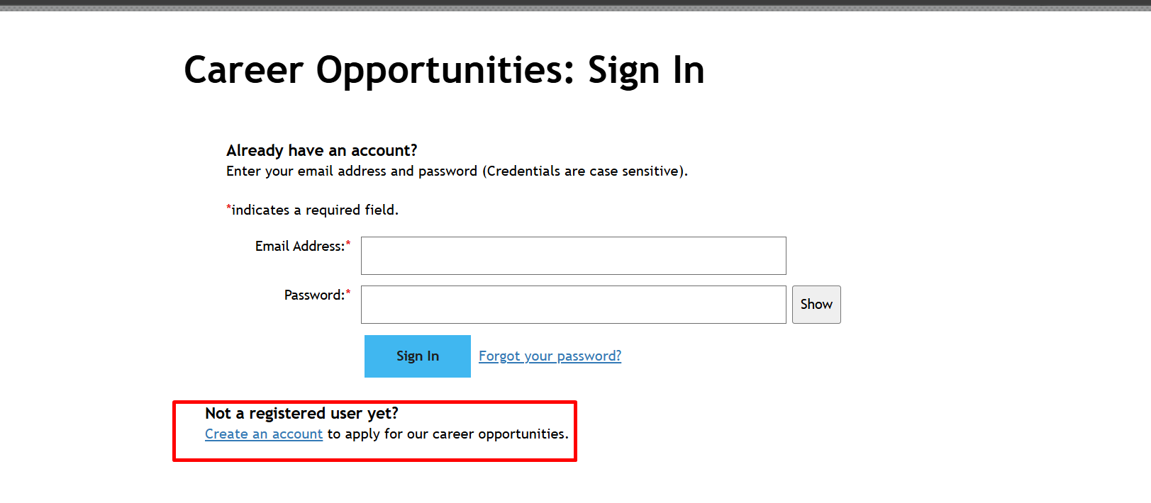
- Input details and click on “Create Account”.

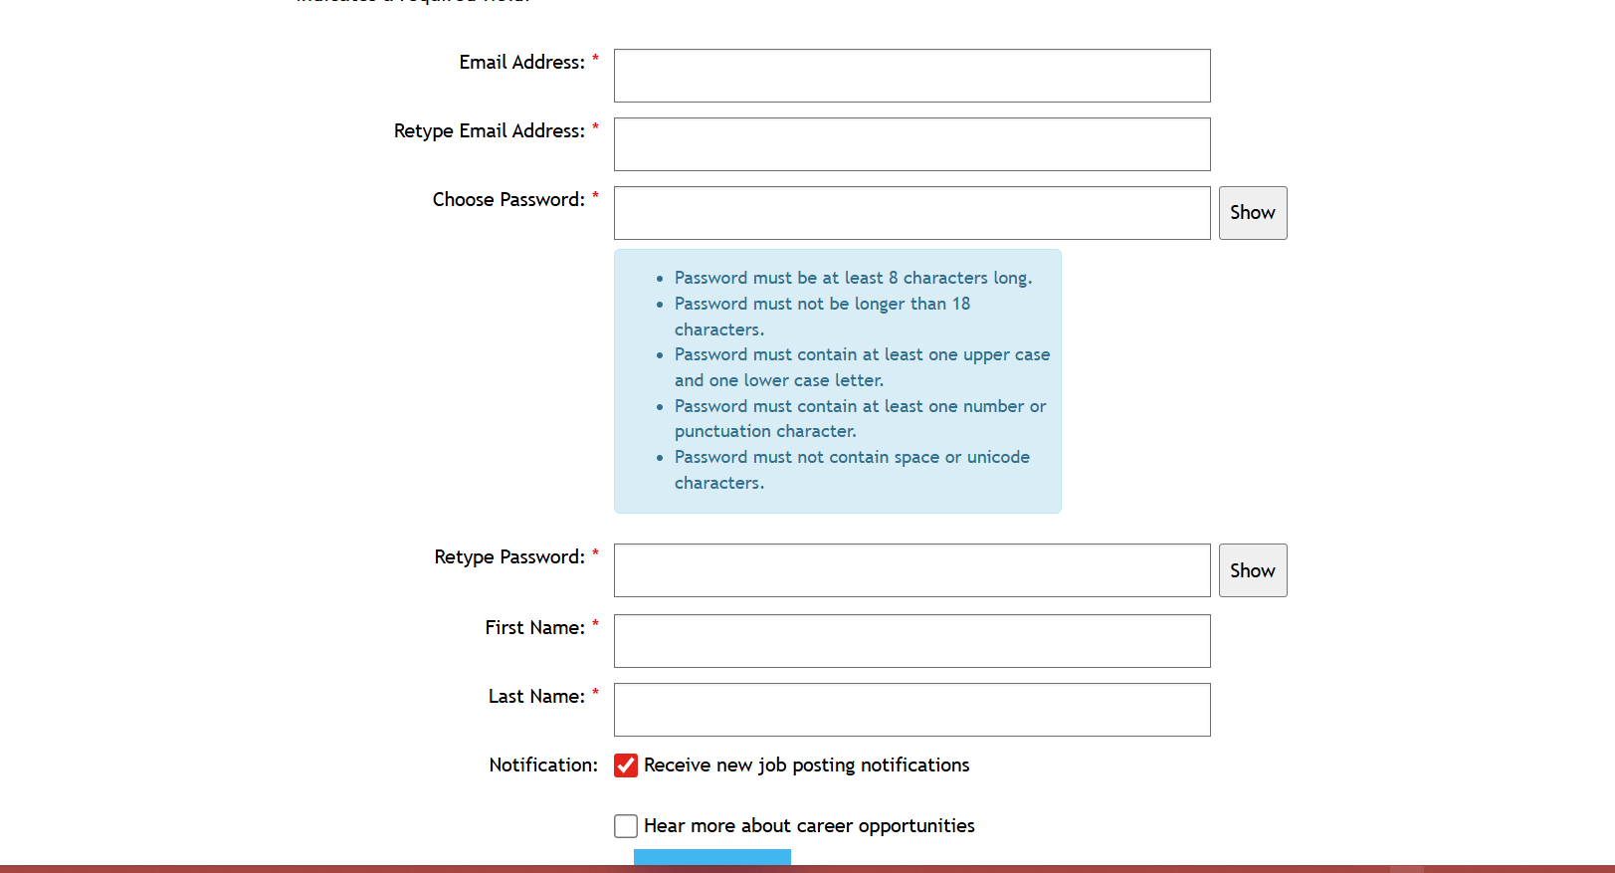

6. Logging In
- Enter email and password.
- Click Sign In.
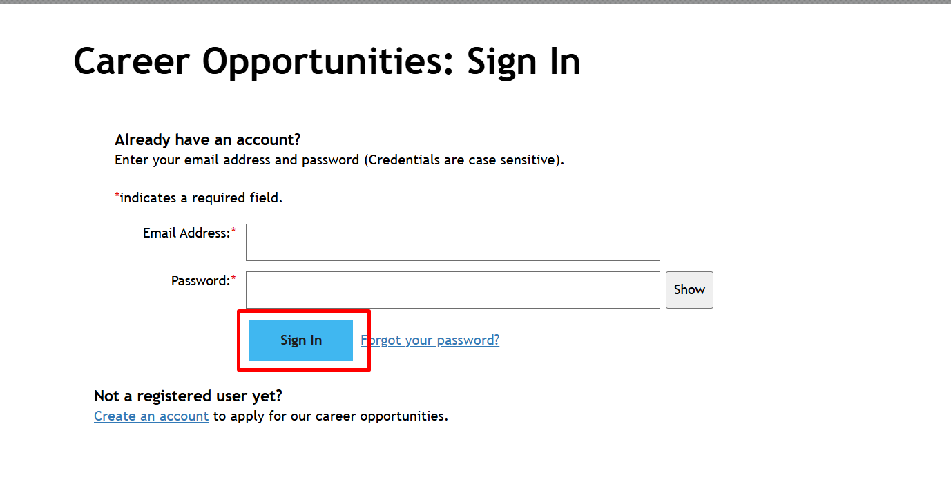

7. Completing the Job Application
Step 1: Upload Resume
Step 2: Enter Personal Information
Step 3: Add Work Experience & Education
Step 4: Answer Application Questions
Step 5: Attach Supporting Documents
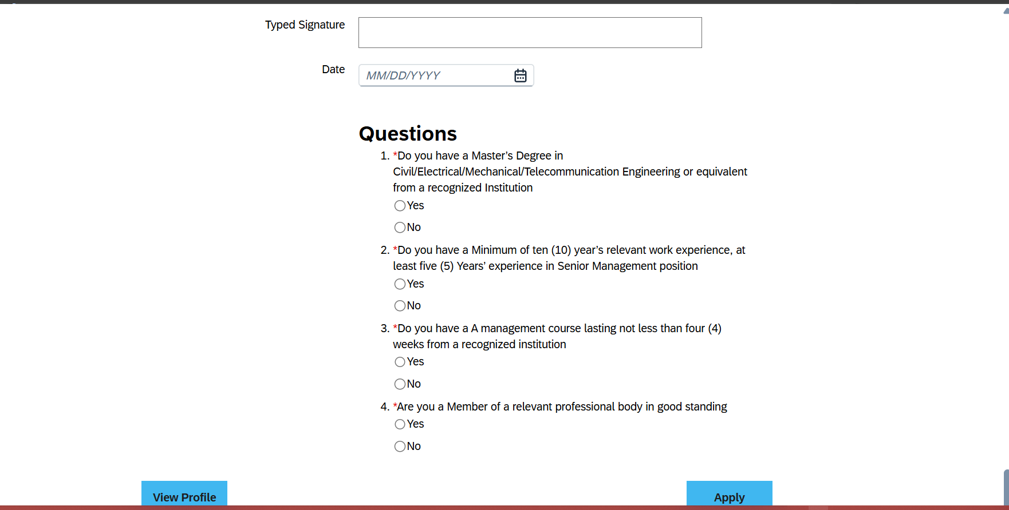

8. Application Confirmation
Confirmation message and email will be sent.
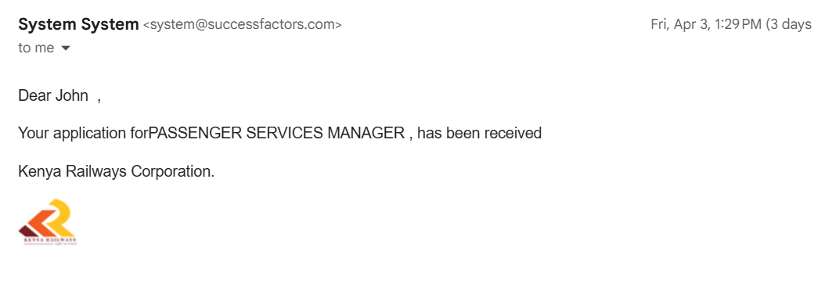

9. Tracking Application Status
- Log in.
- Go to 'My Profile’ go to “Jobs Applied”.
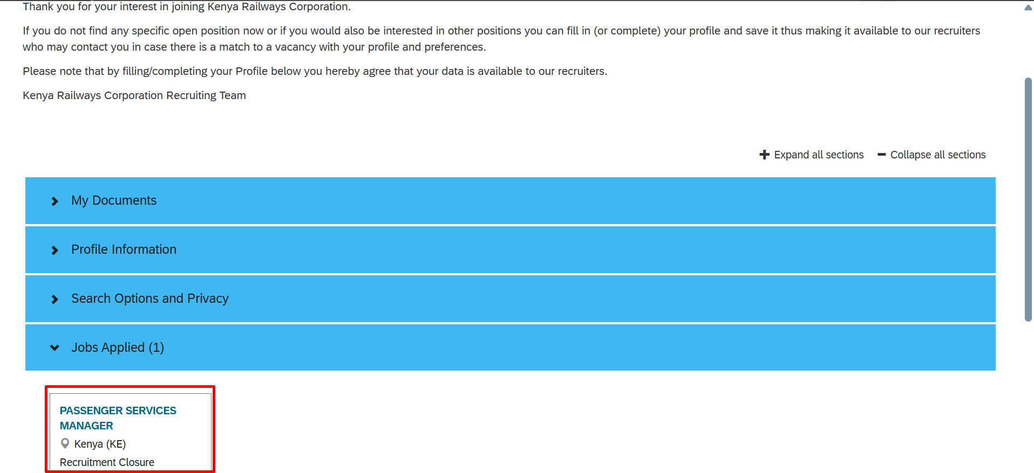

10. Password Reset
- Click ‘Options’ and check ‘settings’.
- Enter email.
- Follow instructions..
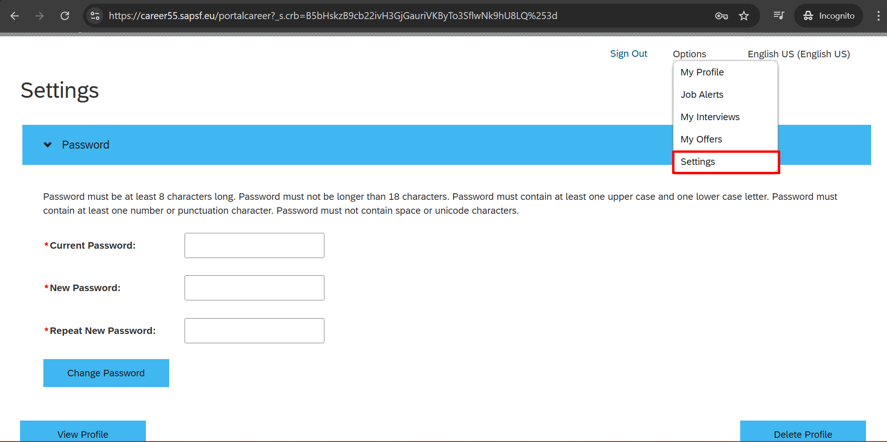

11. How to Confirm Interview
- Candidate will be notified via email in Candidate Profile.
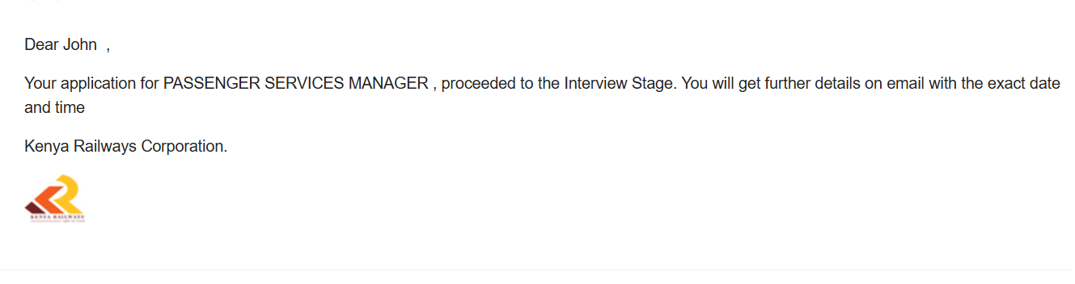
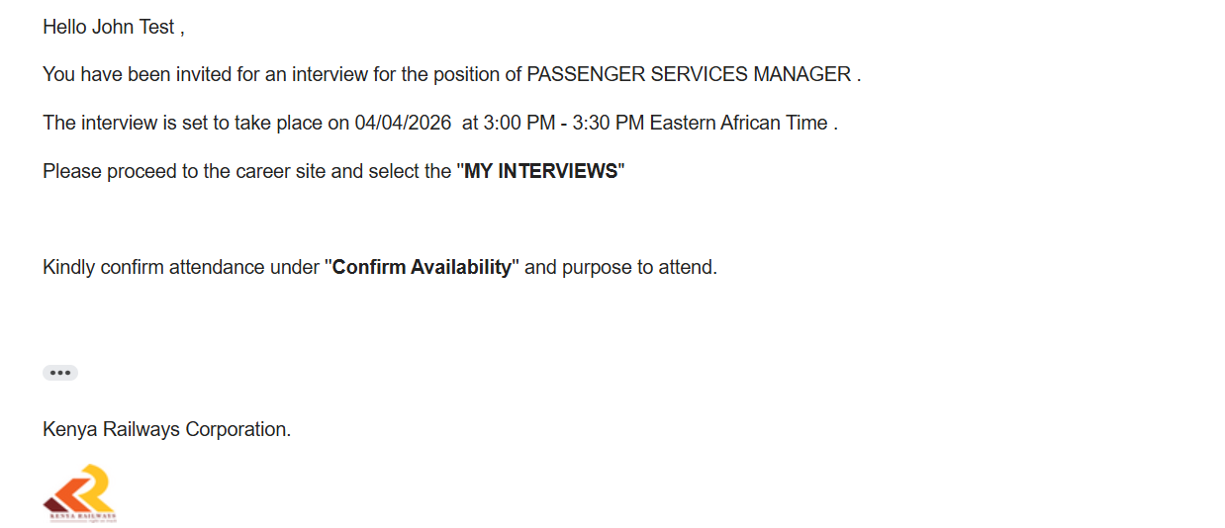
- Log in Kenya Railways Career Portal
- Go to option under “My Interviews”
- Follow instructions..
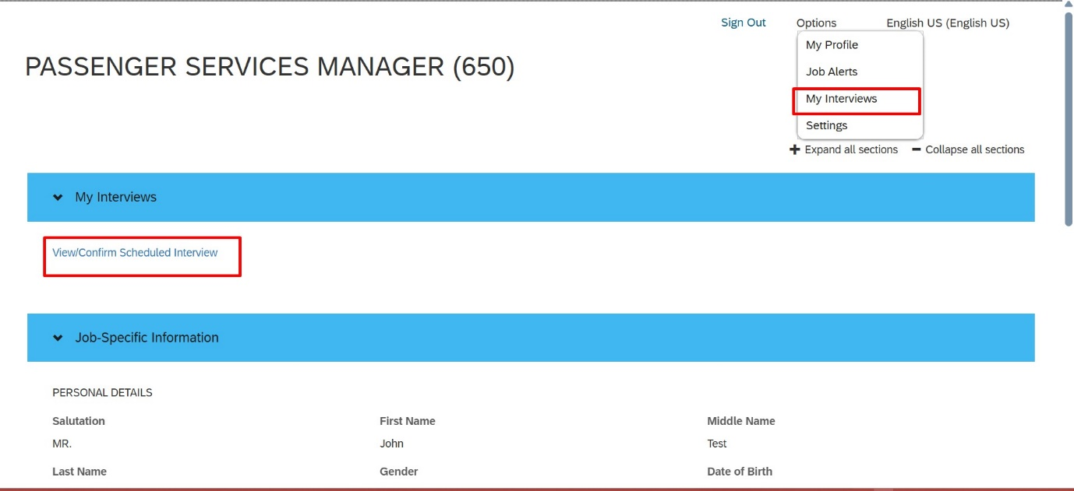
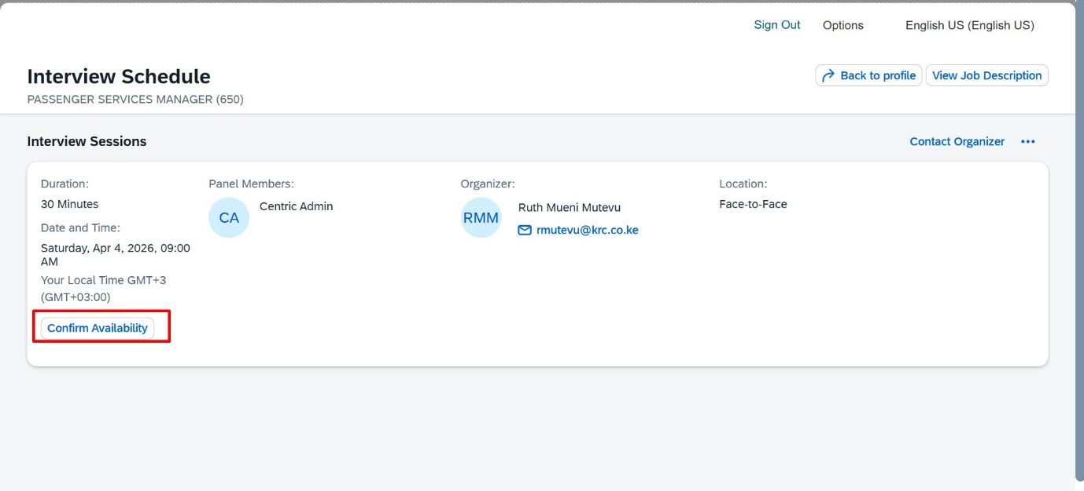

11. How to Confirm Offer Letter
- Candidate will be notified via email in Candidate Profile.
- Log in Kenya Railways Career Portal
- Go to option under “My Interviews”
- Follow instructions.
